Number of 1 bits.

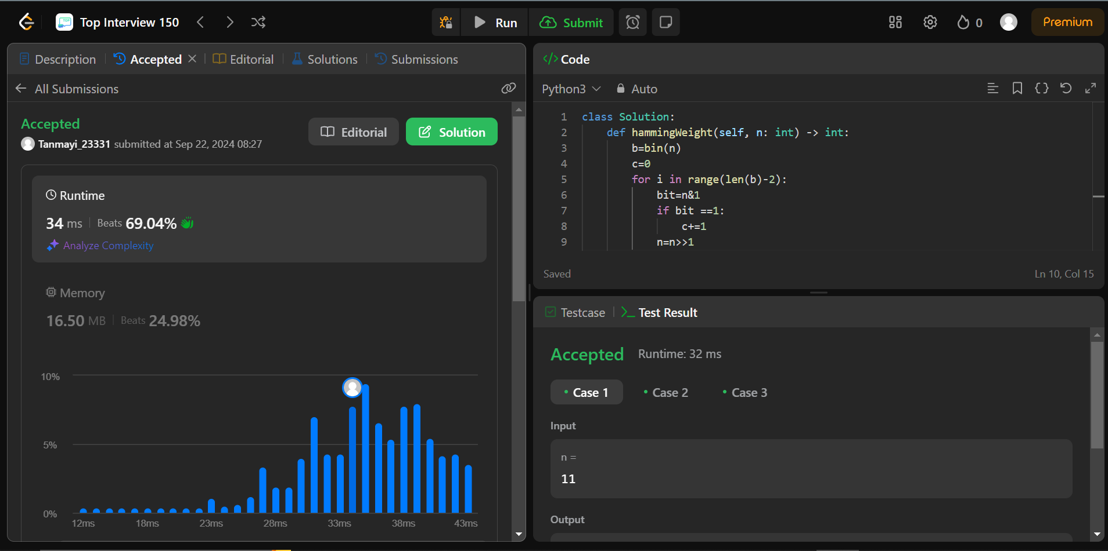

Code:

n=2147483645

b=bin(n)

print(b)

c=0

for i in range(len(b)-2):

bit=n&1

if bit ==1:

c+=1

n=n>>1

print(c)

explain:

we are converting the integer number into its binary representation. Then we define c which is the counter for the 1 bits. We are running a loop for each element and using and operator to get the last bit. Checking if it is 1 or 0, if 1 increase the count.Finally doing right shift to move on to the next bit.